MARSH FARM
OPEN DAY BOOKING FORM
Thursday 6th November 2014

Book online at www.farmattractions.net or follow the below instructions:

- Complete your contact details and attendee details on the left

- Complete the total number of attendees, total cost and sign the form

- Send the completed form to the address below or email to marketing@farmattractions.net

NFAN Ltd
31–33 Victoria Street, Kettering, Northamptonshire, NN16 0BU
Payment:
Payment must be received prior to the event. We can only accept payment via cheque or credit card.
To pay via cheque please make cheques payable to NFAN Ltd and send with your booking form to the address above.
To pay via credit card over the phone please call 01536 513397.
Confirmation:
Once we have received your booking form and payment, we shall confirm your booking back to you.
Attraction Name
Attendee Name 1
Attendee Name 2
Attendee Name 3
If there are more than 3 attendees, please add additional names here

Address
Telephone No
Email Address
Mobile No
HOW TO BOOK

Total Amount Payable (inc VAT): £___________.

Please tick payment method:

Cheque enclosed:

I have phoned the office and paid by Credit Card:

Are you attending the meal on the evening of 5th November?
(details tbc) Yes ____ No _____
Will you be staying at the local hotel on 5th November?
SPONSORS

(details tbc) Yes ___ No _____
We would not be able to offer you such great rates without our sponsors! With thanks to our sponsors Regency Purchasing Group and The Play Inspection Company.

Are you attending the free tour on 5th November at 2pm? (Details tbc)
Yes ___ No _____ Maybe ____


Signature: ………………………………................……

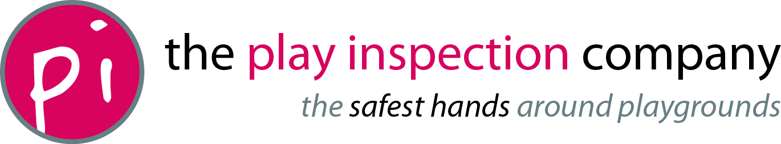
Name: …………………………… Date: ...................

